I : Function Order of Growth (20 points)

1. (5 points) Given the following list of 3 functions:

3 (n² ) 25 + ( 8 n ) (n lg n) - 6

Circle the one ordering below in which the 3 functions appear in increasing asymptotic growth order. That is, find the ordering f₁, f₂, f₃, such that f₁= O(f₂) and f₂= O(f₃).

(a) 3 (n² ) 25 + ( 8 n ) (n lg n) - 6

(b) 25 + ( 8 n ) (n lg n) - 6 3 (n² )

(c) (n lg n) - 6 3 (n² ) 25 + ( 8 n )

2. (5 points) Given the following list of 3 functions:

(1/6)n! (2 ^{lg n}) + 5 9 (lg( lg n))

Circle the one ordering below in which the 3 functions appear in increasing asymptotic growth order. That is, find the ordering f₁, f₂, f₃, such that f₁= O(f₂) and f₂= O(f₃).

(a) (1/6)n! (2 ^{lg n}) + 5 9 (lg( lg n))

(b) (2 ^{lg n}) + 5 9 (lg( lg n)) (1/6)n!

(c) 9 (lg( lg n)) (2 ^{lg n}) + 5 (1/6)n!

For problems 3 and 4, assume that:

f₁= Ω(n lgn) f₂= Ο( n²) f₃= Θ(n) f₄= Ω(1)

For each statement: Circle TRUE if the statement is true.
Circle FALSE if the statement is false.
Circle only one choice.

3. (5 points) f₁= Ω( f₃) TRUE FALSE

Explanation:

f₁= Ω(nlgn) and nlgn = Ω(n) implies that f₁= Ω(n).
n
n²
n lg n
f₁
f₂
1
f₃
f₄
f₁= Ω(n) and f₃= Θ(n) imply that f₁= Ω( f₃).

4. (5 points) f₃= Ο( f₂) TRUE FALSE

Explanation:

Counter-example: f₂= 1

II: Solving a Recurrence (10 points)

In each of the 3 problems below, solve the recurrence by finding a closed-form function f(n) that represents a tight bound on the asymptotic running time of T(n).
That is, find f(n) such that T(n) = Θ (f(n)).
1. (5 points) Solve the recurrence : T(n) = T(n/4) + n/2

[You may assume that T(1) = 1 and that n is a power of 2.]

Circle the one answer that gives a correct closed-form solution for T(n)

(a) Θ(n) (b) Θ(n²) (c) Θ(n lg n)

Explanation : Use the Master Theorem with a=1, b=4, f(n) = n/2
n ^{log}₄¹ = n ⁰ = 1

Ratio test yields: f(n)/n = (n/2)/1 = n/2
This is case 3, so the solution is Θ(f(n)) = Θ(n/2) = Θ(n)

2. (5 points) Solve the recurrence : T(n) = n T( n ) + n
k
[You may assume that T(2) = 1 and that n is of the form 2 ² .]

Circle the one answer that gives a correct closed-form solution for T(n)

(a) Θ(n² lg n) (b) Θ(n lg² n) (c) Θ(n lg(lg n))
Explanation : Some ways to solve this: recursion tree, expand to build a summation, or induction.

Recursion tree has Θ(lglgn) levels and a total of Θ(n) work is done at each level, for a total of Θ(n lg(lg n)).

Induction Hypothesis: T(k) = k lglg k + k/2 Base Case: T(4) = 6
Inductive Step: T(k²) = k T(k) + k²
= k (k lglg k + k/2) + k² = k² lglg k + k² + k²/2
= k² ( lglg k + 1 ) + k²/2 = k² ( lglg k + lg2 ) + k²/2
= k² ( lg(2lg k)) + k²/2 = k² lglg k² + k²/2
III: PseudoCode Analysis (30 points)

Here you’ll use the pseudocode below for two functions Mystery1 and Mystery3.
Mystery1 has three arguments: A : an array of integers; p, r : indices into A

Mystery1(A, p, r)
if p is equal to r
then return 0
q (p+r)/2
g1 Mystery1(A, p, q)
print "Mystery1 result1= ", g1
print contents of A[p]..A[q]
g2 Mystery1(A, q+1, r)
print "Mystery1 result2= ", g2
print contents of A[q+1]..A[r]
g3 Mystery3(A, p, q, r)
print "Mystery3 result= ", g3
print contents of A[p]..A[r]
return g3

Mystery3(A, p, q, r)
initialize integer array B to be empty
bb p
pp p
qq q+1
while pp <= q and qq <= r
do if A[pp] <= A[qq]
then B[bb] A[pp]
pp pp + 1
bb bb + 1
else B[bb] A[qq]
qq qq + 1
bb bb + 1
while qq <= r
do B[bb] A[qq]
qq qq + 1
bb bb + 1
while pp <= q
do B[bb] A[pp]
pp pp + 1
bb bb + 1
a 0
for i p to r
do A[i] B[i]
if i>p
then d |A[i] - A[i-1]|
if d > a
then a d
return a

(a) (10 points) For A = <5,2,16,9,25>, what output is generated by the call Mystery1(A, 1, 5)?

Solution:

A[1..5]= 5 2 16 9 25
Mystery1 result1= 0
A[1..1]= 5
Mystery1 result2= 0
A[2..2]= 2
Mystery3 result= 3
A[1..2]= 2 5
Mystery1 result1= 3
A[1..2]= 2 5
Mystery1 result2= 0
A[3..3]= 16
Mystery3 result= 11
A[1..3]= 2 5 16
Mystery1 result1= 11
A[1..3]= 2 5 16
Mystery1 result1= 0
A[4..4]= 9
Mystery1 result2= 0
A[5..5]= 25
Mystery3 result= 16
A[4..5]= 9 25
Mystery1 result2= 16
A[4..5]= 9 25
Mystery3 result= 9
A[1..5]= 2 5 9 16 25

(b) (5 points) Describe in one or two sentences the mathematical meaning of the result of a call Mystery1(A, 1, length[A]) on an arbitrary integer array A.

Answer: Let A’ be the array A sorted in nondecreasing order. Mystery1 returns the maximum difference between two elements that are adjacent in A’. This is the maximum integer gap between two elements in sorted order.

(c) (10 points) Find a function f(n) that can be used to describe a tight bound on the worst-case asymptotic running time T(n) of Mystery1, where n is the number of elements in array A.
That is, find f(n) such that T(n) = Θ (f(n)).

(You may ignore floors and ceilings in your analysis.)

Solution: Let T₁(n) = time for Mystery 3
Then T(n) = T( n/2 ) + T( n/2 ) + T₁(n)
Ignoring ceilings and floors yields: T(n) = 2T(n/2) + T₁(n)
T₁(n) = Θ (n) [ Mystery3 code is essentially the same as the Merge code from MergeSort. The only difference is the calculation of the maximum gap in the sorted sequence. This does not change the asymptotic running time.]

Thus, T(n) = 2T(n/2) + Θ(n)
Now use the Master Theorem to solve the recurrence.
The ratio test yields Θ(n)/n, which is case 2.
Thus, T(n) = Θ (n lg n)

(d) (5 points) Does the time bound from (c) also describe the best-case and average-case asymptotic running time T(n) of Mystery1? Briefly explain.

Solution: Yes, just as in MergeSort the running time for best-case and average-case inputs is the same as for worst-case inputs: T(n) = Θ (n lg n). This is because:
- the depth of the recursion depends only on the number of elements in the array A and not on the values stored in it;
- the temporary array B must be copied back into array A in the merge step; this operation take time that is linear in the number of elements in the part of A being considered and is independent of the values stored in it.

IV: Patriotic Trees (40 points)

This problem is based on the definition of a PatrioticTree in the Final Exam Handout (see attachment).

1. (10 points) Consider a PatrioticTree TreeNode t and the two TreeNodes t.left and t.right representing its two children. How many different colorings of the 3 TreeNodes t, t.left and t.right are possible? (circle the one correct answer below)

27 13 23 9 17

Explanation: If all possible combinations were possible, the number would be 27. However, the color of t depends on the relationship between t.left.r + t.right.r and t.left.b + t.right.b. Based on this, we make the following observations:
- Case 1: Both children have the same color: If t.left.color is W and t.right.color is W, then t.left.r + t.right.r = t.left.b + t.right.b so t.color is W. This type case contributes 3 possibilities, because similar arguments show that whenever both children are the same color the parent has that same color; this excludes 6 possibilities in which the parent has a different color.
- Case 2: Children have different colors, but one child is W. If t.left.color is R and t.right.color is W, then t.left.r > t.left.b and t.right.r = t.right.b, so t.left.r + t.right.r > t.left.b + t.right.b. In this case, t.color is R. This case contributes 4 possibilities because the case of left subtree’s color W and right subtree’s color R is symmetric and the R/W argument also holds when one subtree is B and one is W. Note that we cannot have one W subtree and a W parent; this excludes 4 possibilities. We also cannot have a non-W parent be a different color than its non-W child; this excludes 4 more possibilities.
- Case 3: Children have different colors and neither child is W. The parent may have any color in this case. This contributes 6 possibilities and excludes none.
The total number of possibilities is therefore 13. Note that of the 27, 14 are excluded.

2. (5 points) An algorithm MAX_R_COLORING accepts as input a list of initialized TreeNodes representing leaves of a PatrioticTree (initialization provides weight and color for each leaf). Assume that the sum of the RedWeights of the leaves exceeds the sum of the BlueWeights of the leaves. Assume also that MAX_R_COLORING always returns a PatrioticTree (built from the leaves up) in which the number of R-colored internal nodes is maximized. Then the number of R-colored internal nodes in the tree built by MAX_R_COLORING is always: (circle the one correct answer below)

2 f 2f - 1 f + 1 f - 1
Explanation: A PatrioticTree that has f leaf nodes has f-1 internal nodes. If the RedWeight total exceeds the BlueWeight total, then all of them can have color R if:
- No internal node has two children that are both internal nodes.
- The only internal node that has 2 leaves as children has two R-colored children. As many direct ancestors as possible of this internal node have R-colored parents that have two R-colored children. As soon as having two R-colored children becomes impossible, as many direct ancestors as possible have R-colored parents that have one W-colored child and one R-colored child.
Descending from the root, let a be the first internal node that is either W or R-colored. Then, all ancestors of a must be R-colored. This is because a’s Red Weight is the sum of the Red Weights of all R-colored leaves. If the root is R-colored, then this sum exceeds the sum of the Blue Weights of all B-colored leaves. Thus, for each ancestor of a (which has one B-colored child), the Red Weight is guaranteed to exceed the Blue Weight.

[Note that similar logic shows that if the root is B-colored, then the tree can be constructed so that all f-1 internal nodes are B-colored. However, this is not necessarily true when the root is W-colored.]

3. (25 points) Given a collection of f leaf nodes, develop the algorithm MAX_R_COLORING as described in Problem 2.
In addition to all assumptions listed in the statement of Problem 2, you may assume that:
- There are w white leaves and they are stored in an array W of TreeNodes
- There are r red leaves and they are stored in an array R of TreeNodes
- There are b blue leaves and they are stored in an array B of TreeNodes

a) (15 points) Provide pseudo-code for the algorithm MAX_R_COLORING

public static TreeNode MAX_R_COLORING (TreeNode[] R, TreeNode[] W, TreeNode[] B) {
TreeNode parent = R[0];
int i;
for (i=1; i<R.length; i++) {
parent = makeParent(parent, R[i]);
}
for (i=0; i<W.length; i++) {
parent = makeParent(parent, W[i]);
}
for (i=0; i<B.length; i++) {
parent = makeParent(parent, B[i]);
}
return parent;

public static TreeNode makeParent(TreeNode leftChild,
TreeNode rightChild) {
String parentColor = "R";
int parentRedWeight = leftChild.r + rightChild.r;
int parentBlueWeight = leftChild.b + rightChild.b;

TreeNode parent = new TreeNode(parentColor, parentRedWeight,
parentBlueWeight, null, leftChild, rightChild);
leftChild.parent = parent;
rightChild.parent = parent;

return parent;
}

b) (5 points) Justify the correctness of the algorithm

Solution: See problem 2’s answer above.

c) (5 points) Establish an upper bound on the algorithm’s worst-case running time in terms of the total number of nodes n.

T(n) = Ο (n).

Explanation: makeParent is O(1). MAX_R_COLORING takes time in O(n)O(1) = O(n) for each of its 3 loops. This gives O(n) overall.
FINAL EXAM HANDOUT

40% of the points on the Final Exam will be based on the representation described in this handout.

We define a new type of tree as follows:
A PatrioticTree is a binary tree of n nodes in which:
- Every internal node has both a left and a right child.
- Each node is labeled with a single color (RED, WHITE or BLUE, which we abbreviate as R, W, or B).
- Each node has a weight. The weight is a pair of integer values and is of the form <r,b>. The first integer value in the pair is the Red Weight of the node = Red Weight of the node’s left child + Red Weight of the node’s right child. The second integer value in the pair is the Blue Weight of the node = Blue Weight of the node’s left child + Blue Weight of the node’s right child. The color of a node is determined as follows:
- R if its Red Weight exceeds its Blue Weight
- B if its Blue Weight exceeds its Red Weight
- W if its Blue Weight equals its Red Weight
- The weight of each W leaf is <0,0>.
- The weight of each R leaf is of the form <r,0>.
- The weight of each B leaf is of the form <0,b>.
W
<0,0>

R
<4,0>

B
<0,5>

R
<3,0>

B
<0,3>

W
<0,0>

W
<3,3>

B
<0,6>

R
<2,0>

B
<2,6>

B
<2,6>

B
<7,8>

B
<0,5>

B
<9,14>

B
<3,8>

EXAMPLE of a PatrioticTree:

In this example:

- there are 8 leaf nodes
- there are 7 internal nodes
(including the root)
- the total number of
nodes is 15
FINAL EXAM HANDOUT
(continued)

For algorithmic purposes, we represent a PatrioticTree as follows:

A TreeNode represents a node of a PatrioticTree. It contains the attributes:
- color: a character representing its color: “R”, “B” or “W”
- r: an integer representing its Red Weight
color
r
parent
left
b
right
- b: an integer representing its Blue Weight
- parent: a pointer to the parent of this node
- left: a pointer to the left subtree of this node
- right: a pointer to the right subtree of this node

You can access a node’s attributes using the “.” notation (e.g. for a TreeNode t, t.color gives its color and t.left accesses its left subtree).
B

6
2

B

8
3

B

5
0

W

3
3

B

8
7

B

6
2

B

14
9

R

0
4

R

0
2

R

0
3

B

5
0

B

3
0

B

6
0

W

0
0

W

0
0

EXAMPLE of how to
represent the PatrioticTree
on the previous page:

1: (20 points) Given the recurrence:

T(n) = T(n/2) + 3T(n/3) + 4T(n/4) + 7n²

(a) (10 points) Show that T(n) = O(n³)

Solution: T(n/4) <= T(n/3) <= T(n/2)

T(n) <= T(n/2) + 3T(n/2) + 4T(n/2) + 7n²

= 8T(n/2) + 7n²

Now use the Master Theorem with a=8, b=2, f(n) = 7n²
n ^{log}₂⁸ = n ³
Ratio test yields: f(n)/n = 7n²/n = 7/n
This is case 1, so the solution is Θ(n ³)
Since T(n) <= Θ(n ³), we obtain T(n) = O(n ³)

(b) (10 points) Show that T(n) = Ω(n^{3/2})

Solution1: T(n/2) >= T(n/3) >= T(n/4)

T(n) >= T(n/4) + 3T(n/4) + 4T(n/4) + 7n²

= 8T(n/4) + 7n²

Now use the Master Theorem with a=8, b=4, f(n) = 7n²
n ^{log}₄⁸ = n ^{3/2}
Ratio test yields: f(n)/n = 7n²/n^{3/2} = 7 n^{1/2}
This is case 3, so the solution is Θ( n² )
Since T(n) = Θ( n² ) which is in Ω( n^{3/2} ), we obtain via transitivity T(n) is in Ω( n^{3/2} ).

Solution2: Observe that T(n) >= 7n² since
(T (n/4) + 3T(n/4) + 4T(n/4)) is positive.
Now, since n² is in Ω( n^{3/2} ),
by transitivity we can conclude that T(n) = Ω( n^{3/2} ).
2: True/False (30 points) Circle TRUE if the statement is true. Circle FALSE if the statement is false. Circle only one choice.

(a) (15 points) If f₁= n 2^{n} , f₂ = 2^{n+1} then f₁= Ο( f₂ )

TRUE FALSE
Explanation:

f₁= Ο( f₂ ) would imply f₁ <= c f₂ for all n >= n₀ which would imply

n 2^{n} <= c 2(2^{n}) and therefore n <= 2 c . This, however, would

require c to depend on n, which violates the conditions for the

definition of O( ).

(b) (15 points) Clustering for dynamically resizable hash tables

Define a dynamically resizable hash table to be one in which, whenever the hash table becomes full, the size of the hash table is doubled, and all entries are removed from the small hash table and inserted into the new, larger hash table.

Consider a hash table H₁ of size m and a hashing function h₁(k) = k mod m. Let H₂ be of size 2m. Suppose that open addressing with linear probing is used for both H₁ and H₂. Let the hashing function for H₂ be h₂(k) = k mod 2m.

If, for the keys k₁, k₂, ..., k_{b} it is the case that
k₁ mod m = k₂ mod m = ... = k_{b} mod m
and when these keys are inserted (in the order given) into H₁ they occupy consecutive slots in H₁, then if only k₁, k₂, ..., k_{b} are inserted into H₂ (in the same order) they also occupy consecutive slots in H₂.

TRUE FALSE
Explanation:

k₁ mod m = k₂ mod m = ... = k_{b} mod m does not imply
k₁ mod 2m = k₂ mod 2m = ... = k_{b} mod 2m

As a counter-example, consider m = 7 , k₁ = 10 , k₂ = 17 , k₃ = 24. All 3 keys hash (under h₁ ) to the value 3. However, under h₂ they do not hash to the same value: 10 mod 14 = 10, 17 mod 14 = 3 and 24 mod 14 = 10.

3: (50 points) This is based on the Exam Handout.
distributed on 11/17 (see attachment).

(a) (5 points) Here we examine the amount of storage required for this representation. If each Key Node counts as one unit of storage and each Neighbor Ring Node also counts as one unit, give (and briefly justify) a tight (upper and lower) bound on the worst-case number of storage units needed for this representation as a function of n, the total number of Key Nodes.

Solution: One for each KeyNode yields n.
There can be neighbors in the worst case; for each there are
n
2

2 NeighborRingNodes.
n
2
n
2
This yields a worst-case total of Θ n + 2 = Θ = Θ(n²)

(b) (5 points) A neighbor triple is a triple of Key Nodes <k₁, k₂, k₃ > such that each pair within the triple has the neighbor relation. (In the example in the exam handout, the nodes with keys a, b, and c are in a neighbor triple.) In the worst case, how many neighbor triples can there be (as a function of n, the total number of Key Nodes)?

Clarification: We consider all neighbor triples containing k₁, k₂, and k₃ to be the same.
n
3
Solution: Θ = Θ(n³)

(c) (40 points) Using the neighbor triple definition in (b):
- Given a reference (pointer) to a Key Node k, give pseudo-code to decide if k is part of a neighbor triple. If k is part of a neighbor triple, the pseudo-code should print out “yes” plus the 3 key values of a neighbor triple. (You need not find all triples; you may stop after finding the first one.) If k is not part of any neighbor triple, the pseudo-code should print out “no”.
- Justify the correctness of your algorithm.
- Give (and justify) a tight (upper and lower) bound on your algorithm’s worst-case asymptotic running time as a function of n, the total number of Key Nodes.

A Solution:

I. findTriple(k1) [Comment: In this pseudocode we rename k to be k1]
tripleFound false
k1Current k1.ring
if k1Current = nil
then do [Comment: check each neighbor of k1 to build a < k1, k2> pair]
k2 k1Current.neighbor.keyNode
k2Current k2.ring
if k2Current = nil
then do [Comment: check each neighbor of k2 to build a < k2, k3> pair]
k3 k2Current.neighbor.keyNode
k3Current k3.ring
if k3Current = null and k3 = k2
then do [Comment: check each neighbor of k3
to build a < k3, k1> pair. 3 pairs yield a triple < k1, k2, k3>]
if k3Current.neighbor.keyNode = k1
then print "yes”, k1.key, k2.key, k3.key
tripleFound true
k3Current k3Current.neighborCW
while k3Current = k3.ring and tripleFound = false
k2Current k2Current.neighborCW
while k2Current = k2.ring and tripleFound = false
k1Current k1Current.neighborCW
while k1Current = k1.ring and tripleFound = false
if tripleFound = false
then print "no"
II. Correctness: A KeyNode k1 is part of a neighbor triple if and only if we can find KeyNodes k2 and k3 such that:
- <k1, k2> is a neighbor pair
- <k2, k3> is a neighbor pair
- <k1, k3> is a neighbor pair
In terms of NeighborRingNodes, we seek k1Current, k2Current and k3Current such that:
- k1Current.neighbor = k2Current and k2Current.neighbor = k1Current
- k2Current.neighbor = k3Current and k3Current.neighbor = k2Current
- k1Current.neighbor = k3Current and k3Current.neighbor = k1Current
If the underlying data structure is correctly represented, then whenever kiCurrent.neighbor = kjCurrent, kjCurrent.neighbor = kiCurrent. Therefore, we need only check that: k1Current.neighbor = k2Current, k2Current.neighbor = k3Current, and k3Current.neighbor = k1Current.
To accomplish this the algorithm contains 3 nested while loops. Each loop traverses a neighbor ring and identifies one of three neighbor pairs. The outer loop traverses k1’s neighbor ring using k1Current to point to the current NeighborRingNode; each ring node points to a neighbor of k1 and therefore yields a pair <k1,k2>. The algorithm uses k2Current to traverse k2’s ring; each ring node points to a neighbor of k2 and therefore yields a pair <k2,k3>. The algorithm uses k3Current to traverse k3’s ring; each ring node points to a neighbor of k3 and therefore yields a pair involving k3. If the neighbor in this pair is k1, this yields a pair <k1,k3> which completes the triple <k1,k2,k3>.
The algorithm checks for special cases such as nil pointers. It also uses a boolean flag tripleFound to short-circuit if it finds a neighbor triple.

III. Running Time: The algorithm’s running time is dominated by the 3 nested while loops, so its time is in Ο (n³). For the lower bound, we can construct a situation in which:
- the n KeyNodes are in 3 groups A, B, C of n/3 each
- each node in A is a neighbor of each node in B
- each node in B is a neighbor of each node in C
- no other nodes are neighbors.
In this situation, there are no neighbor triples but the algorithm must do (n/3)(n/3)(n/3) work to prove this. This worst-case example gives us a worst-case lower bound of Ω (n³), which allows us to conclude that the worst-case running time is Θ (n³).

Note that having all key nodes be neighbors of each other does not force the algorithm to do Ω (n³) work. This is because, for all choices of k1, k2 and k3, the triple <k1,k2,k3> exists. So, if we start with k1, then the first neighbor ring node of k1 that we examine leads us to a neighbor k2 that is definitely part of a triple that includes the pair <k1,k2>. We therefore need not examine the remaining neighbor ring nodes of k1’s ring. Similarly, once we enter k2’s neighbor ring node, we need only examine one other k2 neighbor ring node to find k3 that is part of a <k2,k3> pair. Since the triple <k1,k2,k3> exists, we can find a pointer to k1’s neighbor ring via k3’s neighbor ring. However, we may have to search all of k3’s ring in order to find that pointer. This causes O(n) work. Thus, the first 2 loops degenerate to constant-time operations and the total work is O(n) in the “all neighbors” case.
Exam Handout

This reinforces material from Chapters 1-12. Date Distributed: Friday, 11/17

The open-book exam on Monday, 11/20 will contain a 50-point question based on the scenario described below.

In this problem, there are two types of list nodes:
1) a Key Node that contains the attributes:
key
info
ring
- key: a key value
neighborCCW
neighborCW
neighbor
keyNode
- info: satellite data
- ring: a pointer to a linked list of Neighbor Ring Nodes
We call this list a Neighbor Ring.
2) a Neighbor Ring Node that contains the attributes:
- keyNode: a pointer to the Key Node for this Neighbor Ring
- neighbor: a pointer to a Neighbor Ring Node for a neighbor of this Key Node’s Neighbor Ring
- neighborCCW: a pointer to the next Neighbor Ring Node in this Key Node’s Neighbor Ring (where next is in the counter-clockwise direction)
- neighborCW: a pointer to the next Neighbor Ring Node in this Key Node’s Neighbor Ring (where next is in the clockwise direction)
You can access a node’s attributes using the “.” notation (e.g. for a Key Node k, k.key gives its key and for a Neighbor Ring Node n, n.neighbor gives its neighbor).
The neighbor relation is symmetric: if a is a neighbor of b, then b is a neighbor of a.
You may assume that there is a total of n Key Nodes.

(See Example on Next Page)

[Note: Representations that use neighbor rings are often useful in graphics and geometric modeling applications.]

Example:
- Nodes with key values a and b are neighbors
- Nodes with key values a and c are neighbors
- Nodes with key values b and c are neighbors
- Nodes with key values c and d are neighbors
neighborCCW
neighborCW
neighbor
keyNode
neighborCCW
neighborCW
neighbor
keyNode
neighborCCW
neighborCW
neighbor
keyNode
neighborCCW
neighborCW
neighbor
keyNode
neighborCCW
neighborCW
neighbor
keyNode
key
info
ring
a
key
info
ring
b
key
info
ring
c
key
info
ring
d
neighborCCW
neighborCW
neighbor
keyNode
neighborCCW
neighborCW
neighbor
keyNode
neighborCCW
neighborCW
neighbor
keyNode
3. (10 points) Minimum Spanning Trees: For the undirected, weighted graph below:
A
B
C
D
E
F
G
2
2
1
1
3
4
4
5
6
6
8
7

Show 2 different Minimum Spanning Trees. Draw each using one of the 2 graph copies below. Thicken an edge to make it part of a spanning tree.

What is the sum of the edge weights for each of your Minimum Spanning Trees?

Answer: 16

A
B
C
D
E
F
G
2
2
1
1
3
4
4
5
6
6
8
7
A
B
C
D
E
F
G
2
2
1
1
3
4
4
5
6
6
8
7

4. (5 points) For the directed, weighted graph below, find the shortest path that begins at vertex A and ends at vertex F.

A
B
C
D
E
F
G
2
2
1
1
3
4
4
5
6
6
8
7

- (4 points) List the vertices in the order that they appear on that path

Answer: A, D, F

Dijkstra: A D B C E F G vertex
- A A B D D B predecessor
1 1 2 3 7 9 6 distance

- (1 point) What is the sum of the edge weights of that path?

Answer: 9

I : Multiple Choice (10 points)

1. (5 points) Function Order of Growth

Given the following list of 3 functions:

(n² lg n) - 6 (n lg³ n) + 12n (5n/6)²

Circle the one ordering below in which the 3 functions appear in increasing asymptotic growth order. That is, find the ordering f₁, f₂, f₃, such that f₁= O(f₂) and f₂= O(f₃).

(a) (n lg³ n) + 12n (5n/6)² (n² lg n) - 6

(b) (5n/6)² (n lg³ n) + 12n (n² lg n) - 6

(c) (5n/6)² (n² lg n) - 6 (n lg³ n) + 12n

2. (5 points) Solve a Recurrence

In the problem below, solve the recurrence by finding a closed-form function f(n) that represents a tight bound on the asymptotic running time of T(n).
That is, find f(n) such that T(n) = Θ (f(n)).
Solve the recurrence: T(n) = 9T(n/3) + (n+2)(n-2)

[You may assume that T(1) = 1 and that n is a power of 3.]

Circle the one answer that gives a correct closed-form solution for T(n)

(a) Θ(n) (b) Θ(n²) (c) Θ(n lg n) (d) Θ(n² lg n)
Explanation : Use the Master Theorem with a=9, b=3, f(n) = (n+2)(n-2) = n² – 4

n ^{log}_{b}ª = n ^{log}₃⁹ = n ²

Ratio test shows that : f(n) = Θ(n ^{log}_{b}ª)

This is case 2, so the solution is T(n) = Θ( n ^{log}_{b}ª lg n) = Θ( n² lg n)

II: True/False (15 points)

For each problem in this section: Circle TRUE if the statement is true.
Circle FALSE if the statement is false.
Circle only one choice.

1. (5 points) Function Order of Growth: What can you conclude?

Assume that:

f₁(n)= Ο(2^{n}) f₃(n)= Θ(f₂(n)) f ₃(n)= Ω(n) f₄(n)= Ω(n³)
If we also know that f₃(n) = Ω( f₄(n)), then we can always conclude that f₂(n) = Ω( n³).

TRUE FALSE

Explanation:

f₃(n)= Θ(f₂(n)) (by symmetry) f₂(n)= Θ(f₃(n))
(by Θ definition) f₂(n)= Ω( f₃(n))

f₃(n) = Ω( f₄(n)) and f₄(n)= Ω(n³) (by transitivity) f₃(n)= Ω(n³)

f₂(n)= Ω( f₃(n)) and f₃(n)= Ω(n³) (by transitivity) f₂(n)= Ω(n³)

n
2^{n}
n³
f₁(n)
f₂(n)
f₃(n)
f₄(n)

2. (5 points) Bounds on Alg vs Problem/ Types of input

Given a problem P, suppose that:

- someone designs algorithm A₁ to solve P
- someone designs algorithm A₂ to solve P
- T(A_{i}) represents the asymptotic running time of algorithm A_{i}
- someone constructs a proof that solving an arbitrary instance of P requires at least time in Ω(n).
- the designer of algorithm A₁ claims that algorithm A₁ is in O(2^{n}) for worst-case inputs
- the designer of algorithm A₂ claims that algorithm A₂ is in O(n²) for worst-case inputs

If all these proofs and claims are correct, then we know that

T(A₂) is in Ω(n) and T(A₂) is in Ο(n³)

TRUE FALSE

Explanation:

- If an arbitrary instance of P requires at least time in Ω(n), then T(A₂) is in Ω(n). The worst-case running time of A₂ is O(n²) implies that T(A₂) is in Ο(n²). Since n² is in Ο(n³), by transitivity of O(), we therefore obtain T(A₂) is in Ο(n³).

3. (5 points) The tree shown below on the right can be a DFS tree for some adjacency list representation of the graph shown below on the left.

TRUE FALSE

B
E
C
F
D
A
A
C
B
E
D
F
Tree Edge
Tree Edge
Tree Edge
Tree Edge
Tree Edge
Cross Edge
Back
Edge

Answer: FALSE. Although it is possible for C to be visited before B if the adjacency list has C listed before B, the tree shown has a cross edge, which is illegal for a DFS tree of an undirected graph.

1: True/False (20 points = 10 points each)

For each statement: Circle TRUE if the statement is true.
Circle FALSE if the statement is false.
Circle only one choice.

(a) if f₁= Θ(f₂) then f₁= Ο(f₂) and f₂= Ο(f₁) TRUE FALSE

Explanation:

f₁= Θ(f₂) implies f₁= Ο(f₂) and f₁= Ω(f₂).

f₁= Ω(f₂) implies that: f₁ >= c f₂ for all n >= n₀, which implies that:

(1/c )f₁ >= f₂ for all n >= n₀ (since c is positive).

(1/c )f₁ >= f₂ implies that f₂= Ο(f₁).

(b) if f₁= Ο (n²) and f₂= Ω(n) and f₃= n lgn TRUE FALSE

then f₃= Ο (f₁) and f₃= Ω(f₂)

Explanation:
n²
f₁
Counter-example: f₁ = n and f₂= n²
n lg n
n
f₂

Note: A common mistake was to assume
that f₃= Ο (n²) implies f₃= Ο (f₁)
and f₃= Ω (n) implies f₃= Ω (f₂)

2: Multiple Choice (30 points)

For each statement: circle the one answer that is true.
M
R
L
M
L
M
R

We define a new type of tree as follows: An i/3-tree is one in which:
- Each node may have children of the following types: left-child, middle-child, or right-child. Each node is labeled with its type as follows: L for left-child, M for middle-child and R for right-child (we consider the root to be a middle child).
- Each node has at most i children (see picture on the right for an example of a 2/3-tree).
A complete i/3-tree is an i/3-tree in which each node has exactly i children (clarification: at all levels except the lowest).
3
i
Solution to extra credit:
At each level, each node has i children, and there are different possibilities for those i children. In general, the number of such trees that have j levels is:
3
i
^{j-2}
3
i
total number of nodes in
a i/3 tree that has j-1 levels
Σ _{k=0} i ^{k}

=
5 points
(a) The number of different complete 3/3-trees with 13 nodes is:

(i) 27 (ii) 1 (iii) 3 (iv) 18 (v) 9

Explanation:

For n=13 and i=3, there are 3 levels. The formula above yields 1 in this case.

10 points
(b) The number of different complete 1/3-trees with 3 nodes is:

(i) 27 (ii) 16 (iii) 3 (iv) 18 (v) 9

Explanation:

For n=3 and i=1, there are 3 levels. The formula above yields 9 in this case.

(c) If we construct a 1/3-tree randomly so that, for each node, the probability that it has a left child is the same as the probability that it has a right child and the same as the probability that it has a middle child, then the expected number of middle children (including the root node) in a complete 1/3-tree with 3 total nodes is:
15 points

(i) 9 (ii) 18/16 (iii) 3 (iv) 15/9 (v) 2

Explanation:

The expected number of middle children is
Σ _{k=1} k (Prob( k middle children))
3

= 1(Prob of 1 middle child) + 2(Prob of 2 middle children) + 3(Prob of 3 middle children)

Now, the probability of having k middle children = (number of outcomes containing k middle children)/(total number of outcomes).

Total number of outcomes is the answer to (c), which is 9.

Number of outcomes containing 1 middle child = 4
Number of outcomes containing 2 middle children = 4
Number of outcomes containing 3 middle children = 1

Prob of 1 middle child = 4/9
Prob of 2 middle children = 4/9
Prob of 3 middle children = 1/9

The expected number of middle children = 1(4/9) + 2(4/9) + 3(1/9) = 15/9

Extra Credit:
20 points
The number of different complete 2/3-trees with 7 nodes is:

(i) 27 (ii) 16 (iii) 3 (iv) 18 (v) 9

Explanation:
For n=7 and i=2, there are 3 levels. The formula above yields 27 in this case.

Derive a general formula for the number of different complete i/3-trees, where the tree has j levels.
Answer: See the formula above on previous page.
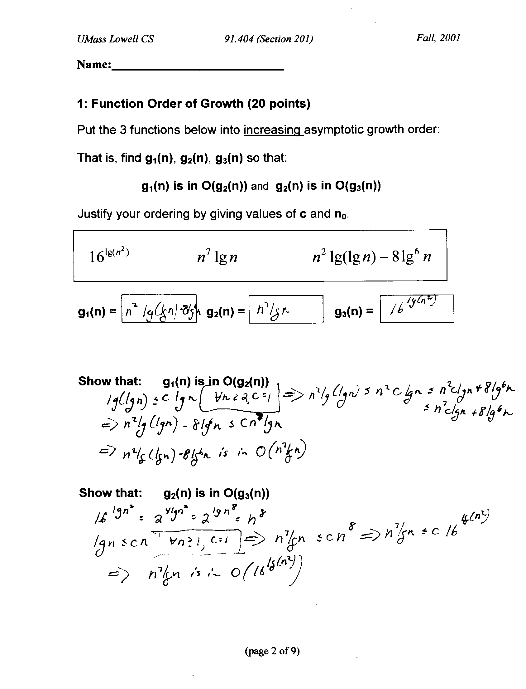
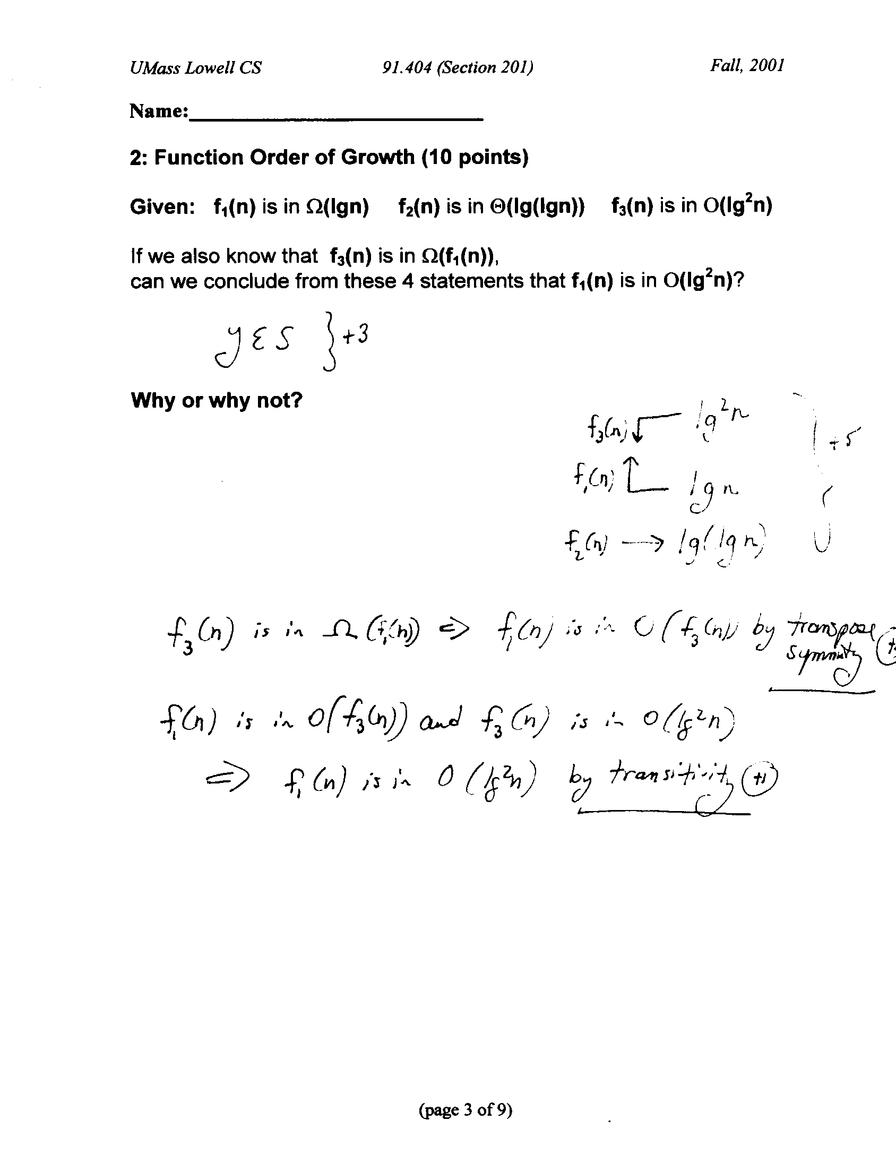
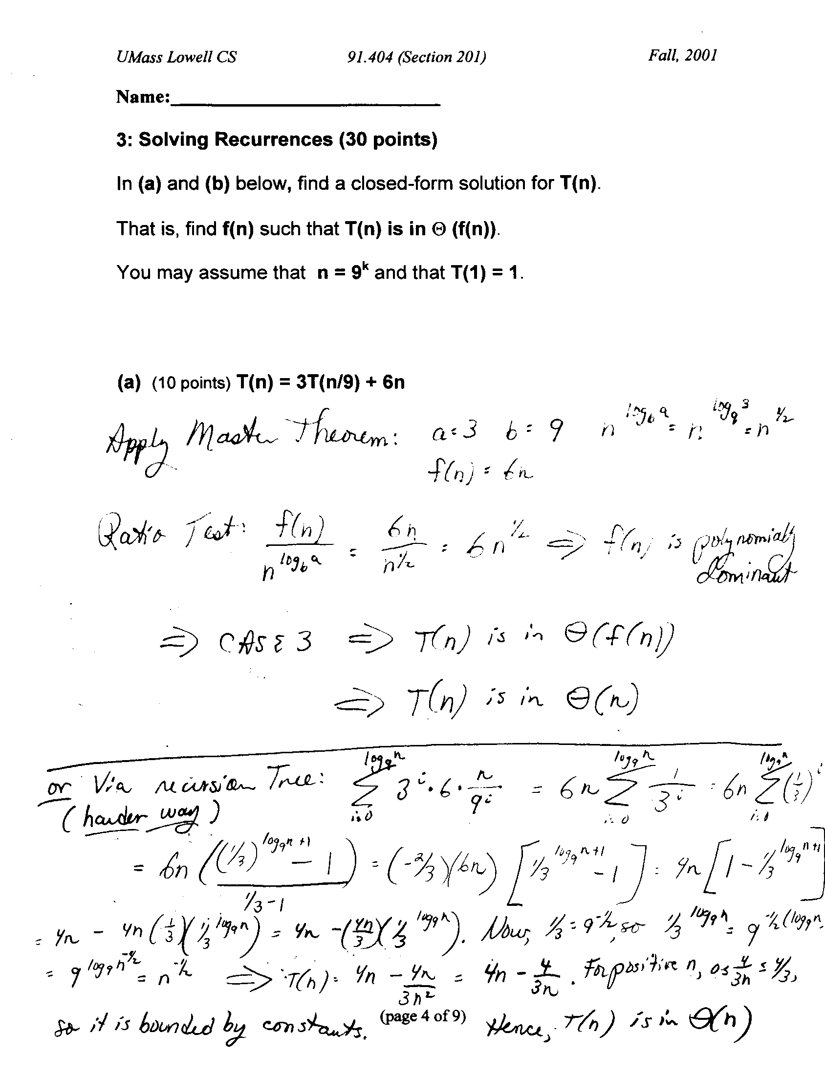
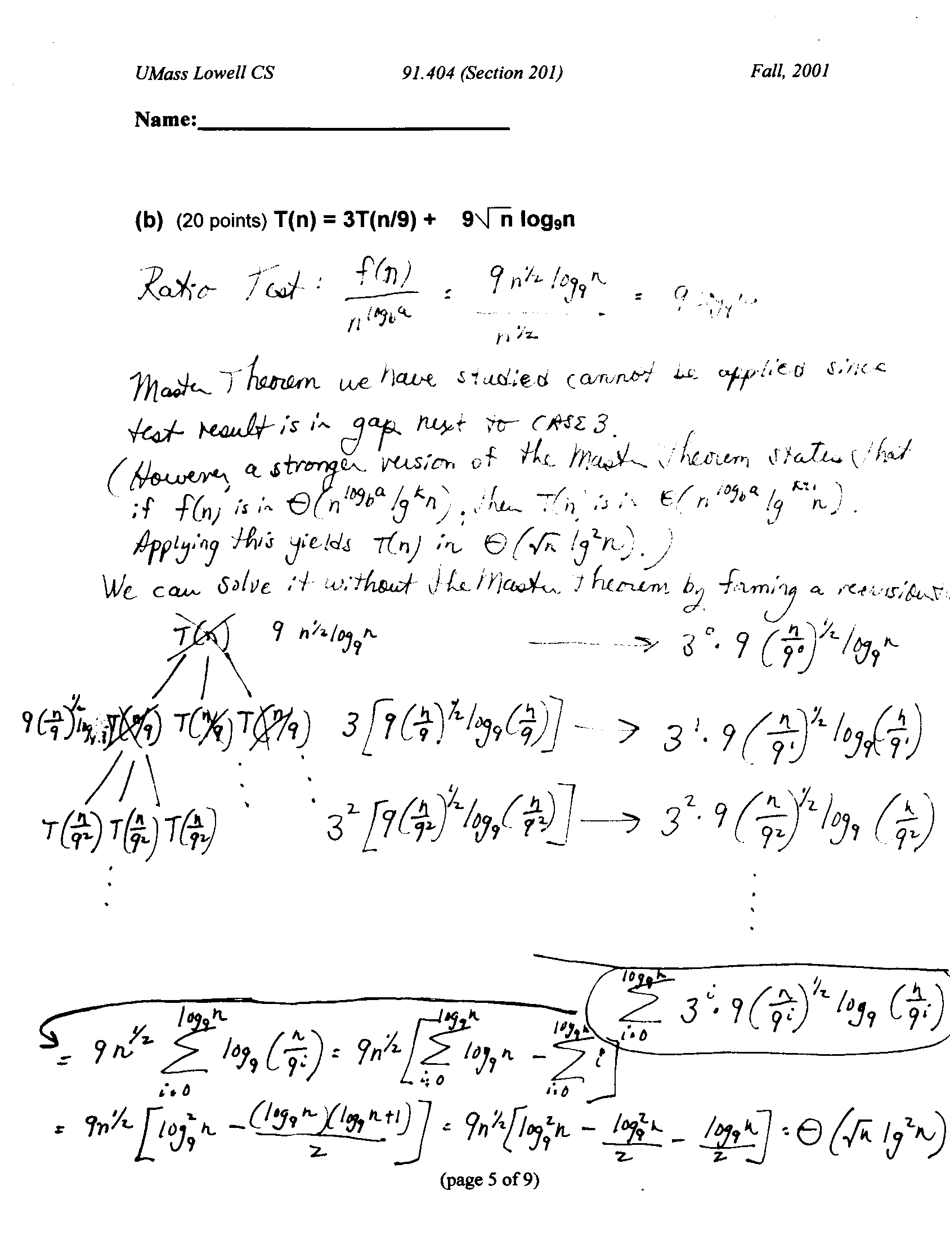

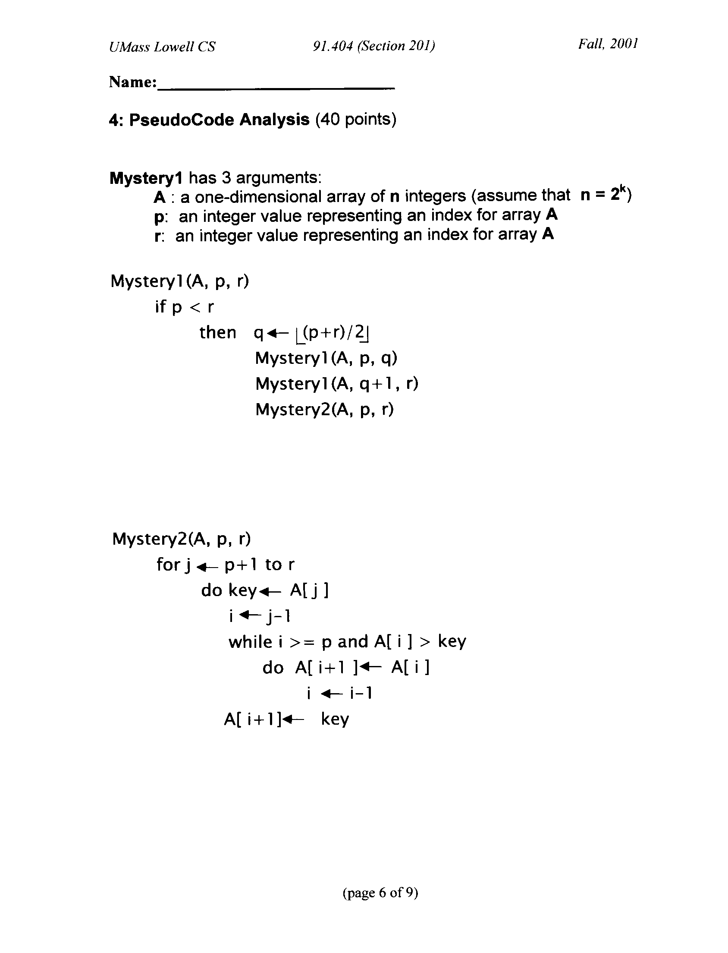
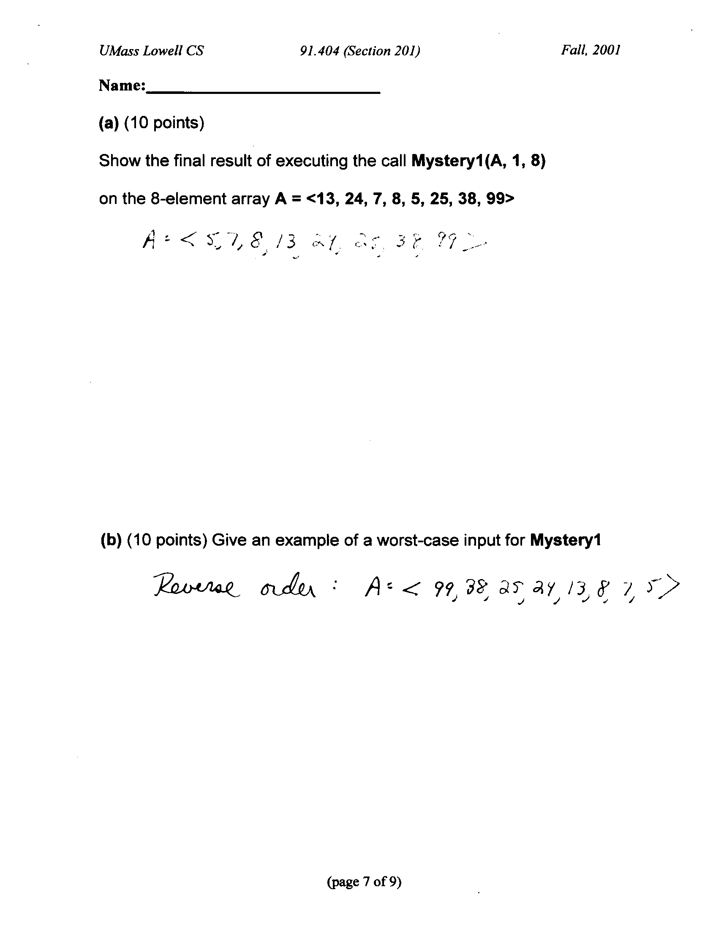
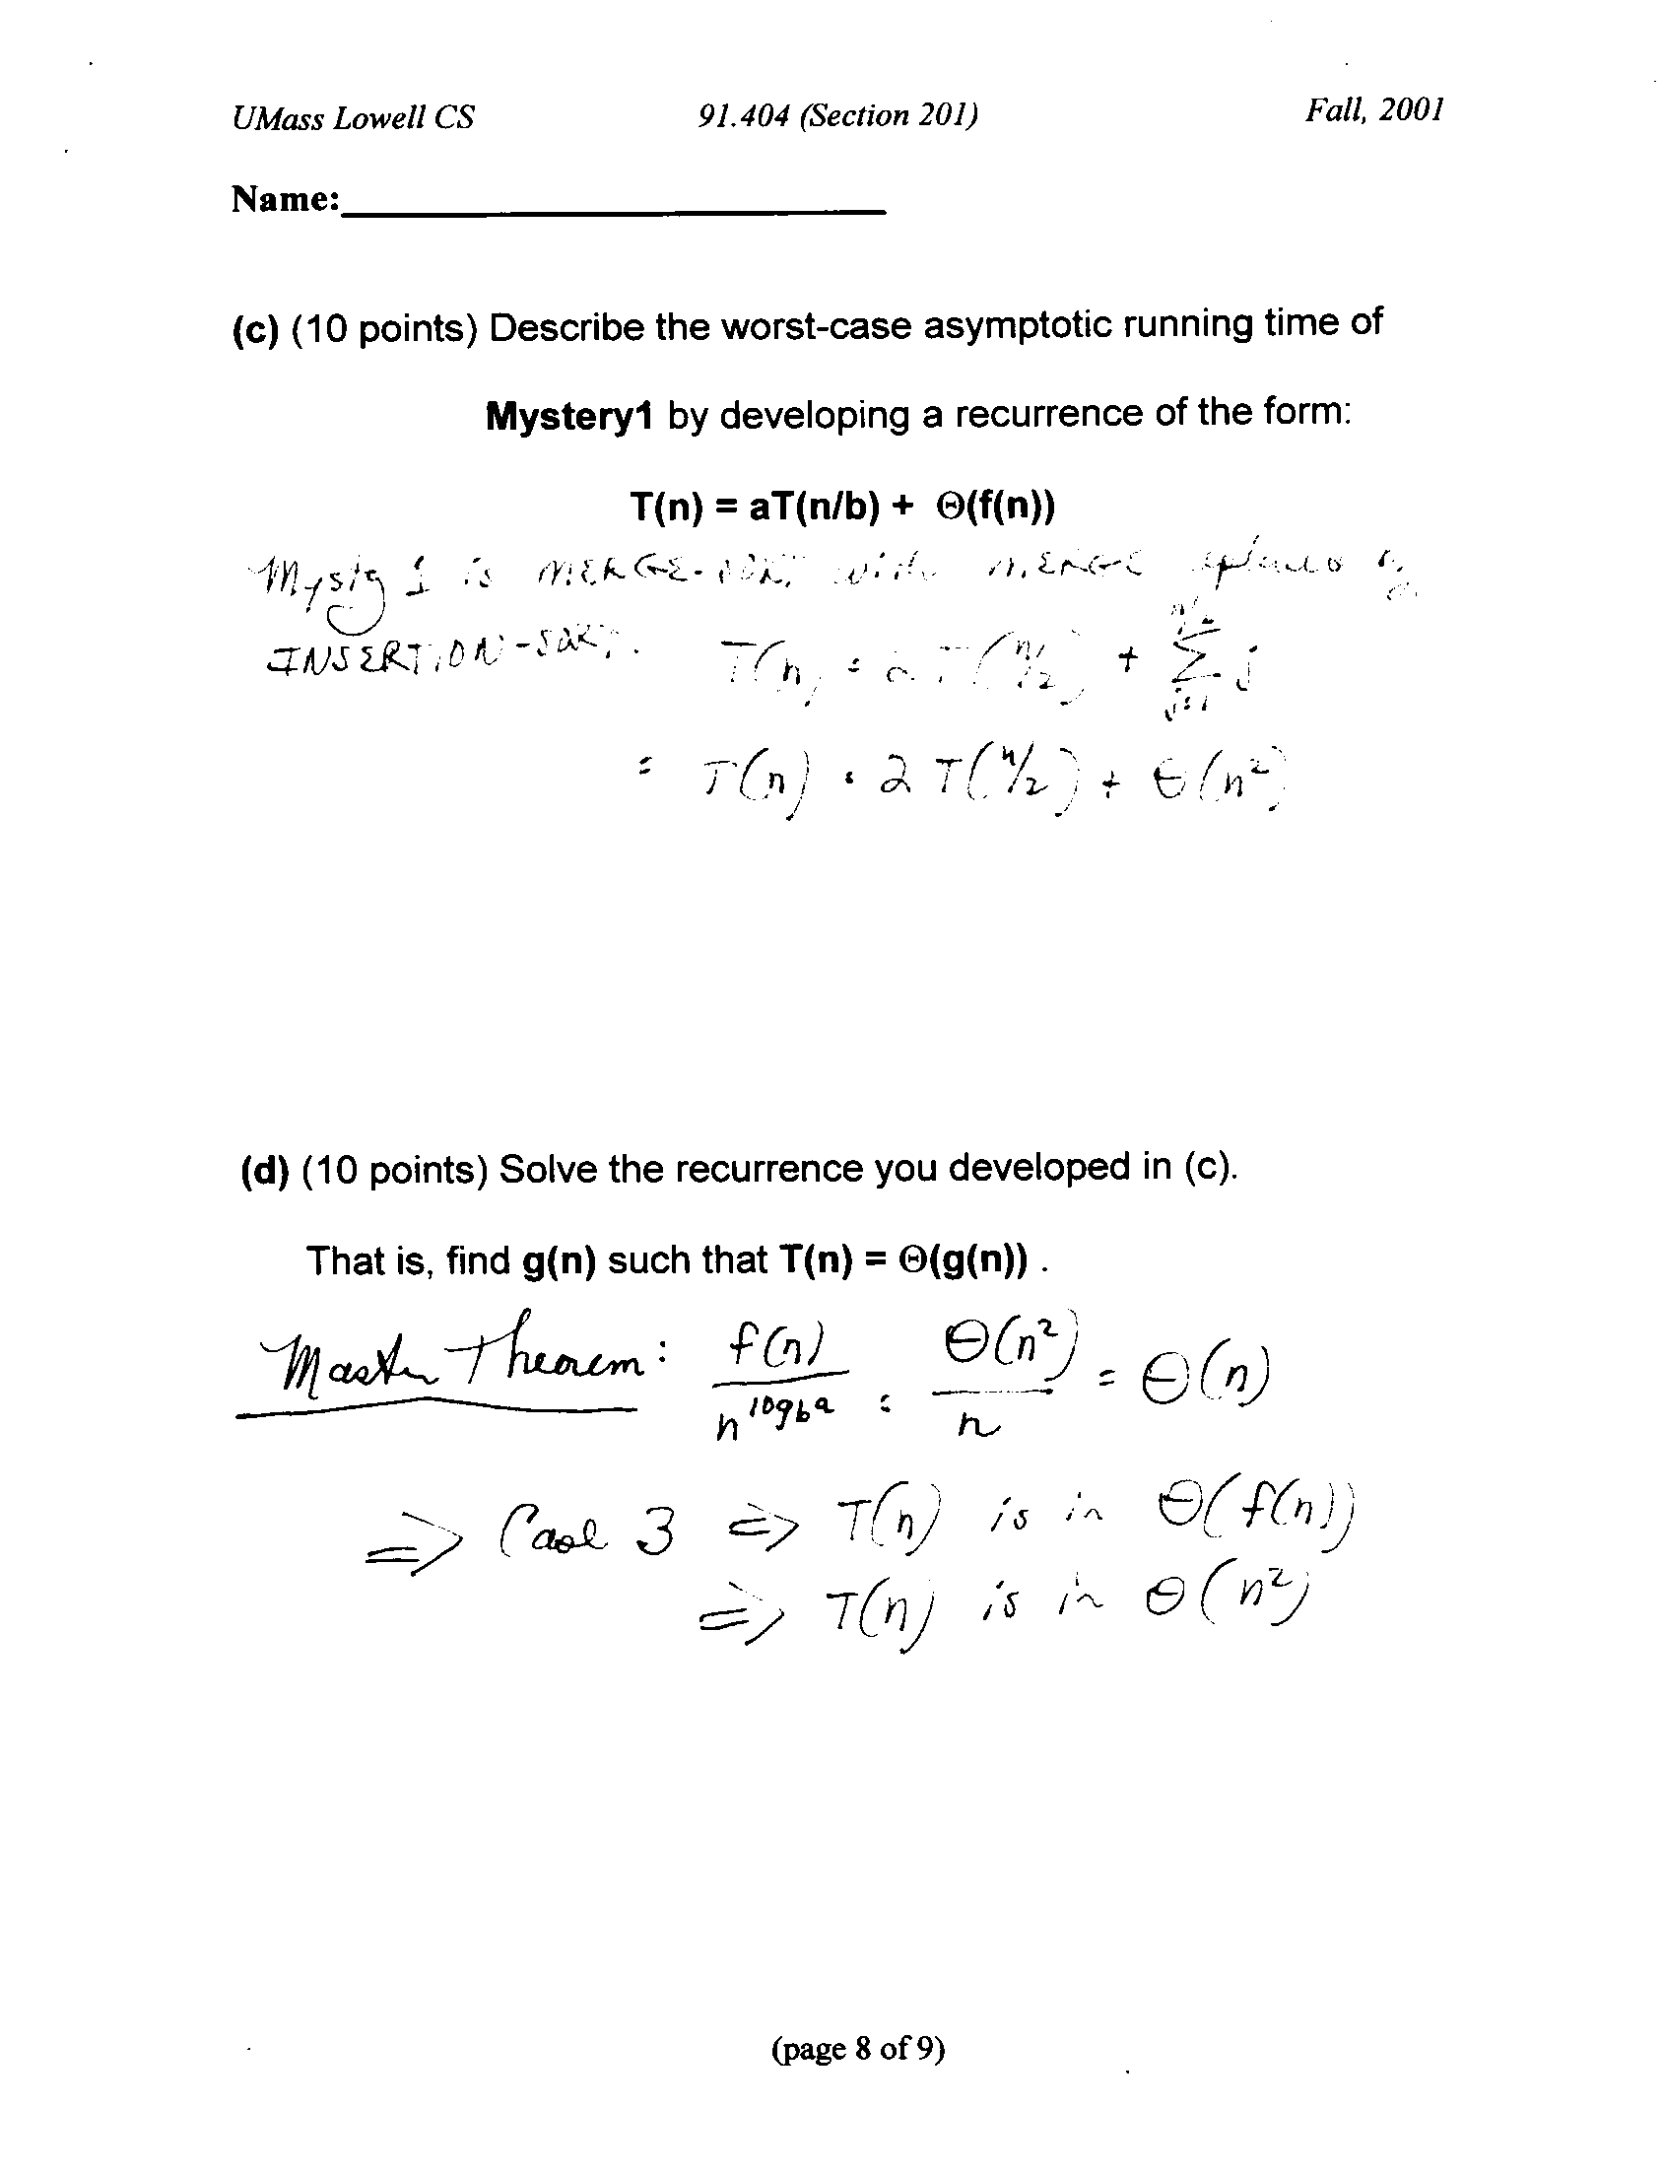

3. (50 points) This question is based on the Exam Handout distributed on 10/27 (see attachment to exam).
Clarifications:
- The delivery schedule S_{i} only needs to contain the messageID, not the entire message.
- Message processing algorithm operates on entire queue to produce Delivery Schedule; no new messages added during this processing.

For a single node v_{i}:

(a) (5 points) Where in the message processing algorithm is sorting required in order to produce S_{i} ? Explain.
Explanation:
Ordering in delivery schedule depends on: (1) message priority and (2) for equal priorities, the arrival order in the queue. To satisfy (1), messages must be sorted by (non-increasing) delivery priority. Arrival order in the queue is given and does not require a sort as long as the sort on priorities is stable. Priority sort must occur before or during formation of the delivery schedule.

(b) (30 points) Assuming that fast asymptotic running time is the most important judgment criterion, what type of sorting algorithm(s) is (are) appropriate for use within the message processing algorithm?
Justify your answer. For each sorting algorithm that you select, your answer should describe the algorithm by writing pseudo-code and stating:
(i) whether it is a comparison-based sort or a non-comparison-based sort
(ii) in more detail what type of sorting algorithm it is. For example, is it a MergeSort? an InsertionSort? a HeapSort? a BucketSort? a RadixSort? A variation on one of these types?
(iii) the worst-case asymptotic running time
(iv) the worst-case size of the delivery list (clarification: this is S_{i})
(v) the amount of extra storage you use (for data structures other than C_{i}, Q_{i}, S_{i})

Note: You need not write out pseudo-code that appears in our textbook; simply cite the page reference. However, if you modify pseudo-code that appears in our textbook, you must write pseudo-code for your modifications. You may assume the existence of a queue data structure that has the following O(1) time operations: enQueue(Q, x), deQueue(Q,x), (clarification: and deQueue(Q)) isEmpty(Q). You may also assume that the operations dynamically allocate storage as needed.

Pseudo-Code for Delivery Schedule Construction for a node:
Note: assumptions:
- Q_{i} is initialized to contain the messages for node v_{i}.
- 10 buckets (queues) B[1]....B[10] are initialized to empty
- We use an Object-Oriented notation below

buildS() {
// Put each message in a priority bucket
while(not (Q_{i}.isEmpty()))
do m Q_{i}.deQueue()
B[m.priority].enQueue(m);

// Transfer buckets into Delivery Schedule
for i 10 downto 1 by -1
do while(not (B[i].isEmpty()))
do m B[i].deQueue()
S_{i}.enQueue( m.messageID )

(i) We know ahead of time that each delivery priority is an integer between 1 and 10, so we can use a non-comparison-based sort to determine the order in which messages appear in the delivery schedule. We create 10 buckets – one for each priority. For each priority value, we add messages to the bucket’s queue in the order in which they appear in the message queue; this guarantees that the correct ordering will be enforced in the event of priority ties and removes the need to sort within each bucket. Because there is no comparison-based sorting within each bucket, this bucket sort is a purely non-comparison-based sort.

(ii) This sort is a bucket sort, with one bucket per priority value. We do not need to sort inside each bucket because the queue ordering suffices and our sort is stable. Note that our bucket sort differs from the bucket sort in our text. In the text all the key values are mapped onto a unit-interval, put into n buckets (if n is the number of elements being sorted), and then each bucket is sorted. In our bucket sort here, we use one bucket for each priority value; our number of buckets is independent of the number of messages.

(iii) Assuming that the message queue stores messages in the order in which they were received, in the worst case our bucket sort requires Θ(m_{i}) time. This is because each message is examined once as it is put onto a queue B[i]. Each message is also processed once to add it to the delivery list. Note that the text’s bucket sort requires Ο(n) expected time; it is not linear worst case time because each bucket must be sorted. We do not need to sort within each bucket, so we can achieve Θ(m_{i}) time.

(iv) In the worst case our bucket sort creates a delivery schedule that contains Θ(m_{i}) messages.

(v) In the worst case our bucket sort uses Θ(m_{i}) extra storage

Note: There are other good ways to achieve a linear-time (worst-case) result here (e.g. counting sort). A purely comparison-based sort requires Ω(n lg n) time and is therefore too slow for this problem in which we specified that fast asymptotic running time is the most important consideration.

(c) (15 points) Describe how your results for (b) change if we change our assumptions so that a message priority may have any integer value larger than 0.

Revised Pseudo-Code for Delivery Schedule Construction for a node:
Note: Assume: Q_{i} is initialized to contain the messages for node v_{i}.
buildS() {
MergeSort(Q, 1, m_{i} )
while(not (Q_{i}.isEmpty()))
do m Q_{i}.deQueue()
S_{i}.enQueue( m.messageID )

(i) Because we cannot any longer make a strong assumption about the priority values, a linear-time (worst-case) sort is now not appropriate. We switch to a comparison-based sort with Θ(m_{i} lg m_{i}) running time. It must be a stable sort because it must preserve the ordering of elements in the queue that have the same priority value.

(ii) Because MergeSort is stable, we use MergeSort.

(iii) Assuming that the message queue stores messages in the order in which they were received, in the worst case our bucket sort requires Θ (m_{i} lg m_{i}) time.

(iv) In the worst case the delivery schedule still contains Θ(m_{i}) messages.

(v) In the worst case our revised algorithm uses Θ(m_{i}) extra storage if MergeSort does not sort in place.

Note: Alternatively, we could still use a bucket sort, but instead of using one bucket per priority we could use the text’s bucket sort approach. If we do this, we must use a stable sort within each bucket. We only get a linear-time expected running time result in this case.
Exam Handout

This reinforces material from Chapters 1-11. Date Distributed: Friday, 10/27

The open-book exam on Wednesday, 11/1 will contain a 50-point question based on the scenario described below.

Suppose that you are working for a company that designs message processing algorithms for managing message deliveries on a network. For the purposes of the algorithm, the network is modeled as a collection of vertices in an undirected graph G (refer to Chapter 5 if necessary for graph definitions). Each vertex represents a node in the network. If there is a direct network connection between two nodes in the network, then the vertices representing those two nodes have an edge in the graph G. (Note: We assume that two nodes have a direct network connection if and only if a message sent from one node to the other does not need to pass through any additional nodes in the network.) Each node can only send messages to nodes to which it is directly connected.
Each message consists of a header and a body. The header consists of metadata that describes the message: a message ID, its destination list and its delivery priority. A destination is another node in the network to which the message must be sent; we represent as an integer (e.g. 0 for vertex v₀). A destination list is an ordered list of destinations. The message must visit its destinations in the order in which they appear in its destination list: i.e. visit the first, then the second, and, ultimately, the last. The message’s delivery priority is an integer in between 1 and 10, where 10 is the highest priority value. The message ID is a unique integer for each message.
Each node/vertex v_{i} has:
- a message processor P_{i} that can execute algorithms;
- a FIFO message queue Q_{i} containing m_{i} messages;
- a list C_{i} of the nodes to which it is directly connected.
When a message arrives at v_{i}, the first destination in its destination list (which is v_{i}) is removed from the message header. If v_{i} is the final destination (that is, the destination list is now empty), the message is not added to Q_{i}. If the next destination (which is now first in the destination list) is not in C_{i}, the message is not added to Q_{i}. Otherwise, the message is added to Q_{i}.
The message processing algorithm that executes on P_{i} must examine Q_{i} and produce a delivery schedule S_{i}. The schedule S_{i} lists the messages that v_{i} will send. In S_{i}, the messages appear in the order in which they will be sent. This order is determined based on the delivery priority and the order in which the messages appear in the message queue Q_{i}. The order is consistent with the delivery priorities and the arrival order in Q_{i} is used to break ties.
v₁
v₂
v₃
2
C₁
1
C₂
3
2
C₃
Example:
messageID: 6
destinationList: 1
priority: 8
messageID: 5
destinationList: 3
priority: 8
messageID: 4
destinationList: 1
priority: 6
S₁
messageID: 2
messageID: 1
messageID: 2
destinationList: 2
priority: 10
messageID: 1
destinationList: 2, 3
priority: 5
S₂
messageID: 5
messageID: 6
messageID: 4
These will remain the same as algorithm(s) execute
These will change as algorithm(s) execute.
Here we show an example for one time period.
v₁
Q₁
Q₂
v₂
G

messageID: 3
destinationList: 2
priority: 1
Q₃
S₃
messageID: 3
v₃

